CW SKIMMER WITH LOGGERS AND GSDR/PSDR DERIVATIVES

Objectives:

- Control the SDR Radio simultaneously with the logging program(s) and CW Skimmer and synchronize the (optional) “slave radio” for TX on SDR’s frequency.
- Be able to revert to and continue to listen to DXPed’s frequency after having observed calls to DXP on CW Skimmer window, selected convenient Split TX frequency and placed a call.
The best solution for the first objective was the use of the “DDUtil” router application, written by K5FR (http://k5fr.com/DDUtilV3wiki/index.php?title=Main_Page ).
This application offers control of SDR radio (compatible with Flex/Kenwood commands) by several command applications without conflicts. If SDR is just a receiver or a low-power TRX, DDUtil also offers a possibility to use an existing “classic” TRX as transmitter, synchronized to SDR’s frequency by DDUtil.

Concerning the second objective, as for now, each click on CWS waterfall/frequency causes SDR VFO to jump and stay on this frequency. This is OK for “normal” operation and multiplier chasing during contests. But not OK for listening to DXP and calling him on the Split frequency.
With a non-SDR TRX this is easy, by listening on VFO A and calling on VFO B or vice-versa. But a “classic” TRX doesn’t offer the wideband vision of all signals simultaneously and working DXP station in a big pileup becomes more difficult than using an SDR connected to the antenna or to a wideband IF of a “classic” TRX.

Installation of additional applications like “Commander” and “Skimmer –to Commander” have offered the solution for reverting to DXP frequency after placing a call on the Split frequency (CWS click moved TX to VFO B frequency). But, apart from additional PC load, the procedure of switching between Simplex and Split modes, as well as between CW and SSB and SSB Simplex/SSB Split was not so convenient.

After a lot of cut-and-try, I found an almost “perfect” solution, which was “in a front of my nose” and which I have overseen during setup of my system before the purchase of CWS. The solution was already there within DDUtil.

On DDUtil site http://k5fr.com/DDUtilV3wiki/index.php?title=Ports I found:
***********************************************************************************************************

“Special (DDUtil) Ports
The following ports are used for special purposes and not intended for normal RCP programs.
- CWS this is a special port configured especially for CW Skimmer users to be able to click in the CWS water fall window and QSY either VFO A or VFO B depending on how the radio is configured. This is especially handy for pile-ups when you hear the DX station (working split) call someone and you can see that person in the water fall window answering. With this feature just click the answering station and you've nailed the frequency where the DX station is listening.

The following table defines the results of using different operating configurations when clicking the CWS water fall.”
Radio Mode |  |  |  | Sets VFO Freq
RX1 | RX2 | Split | Diver | VFO A | VFO B | TX VFO
x |  |  |  | x
x |  | x |  |  | x
x | x |  |  | x
x | x |  | x | x | x
x | x | x | x |  |  | x

More information on using the CWS Port is found on W9OY's Blog web page:
http://w9oy-sdr.blogspot.fr/2011/03/cat-primer-skimmer-dope.html

Lee says (after describing different CAT commands):
“I noticed Skimmer has 2 Radio ports in its set up menu.”
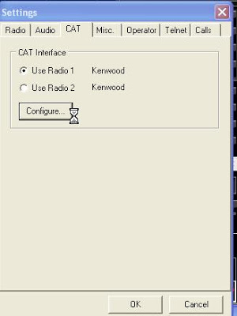

“I reasoned if I could address 2 ports I could make the output from each do different things. What I wanted was a way to make Skimmer control the TRANSMIT freq instead of the RX freq.”

“The virtual com port system allows you to set up virtual serial port connections between 2 programs. On Radio 1, Skimmer connects to DDUTIL over the pair 9-19”
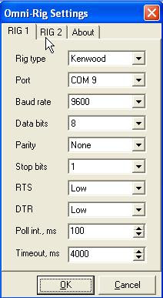 | 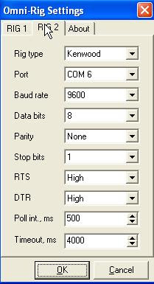
“On radio 2 Skimmer connects Radio 2 to DDUTIL using the pair 6-16”

“Here are the DDUTIL connections:”
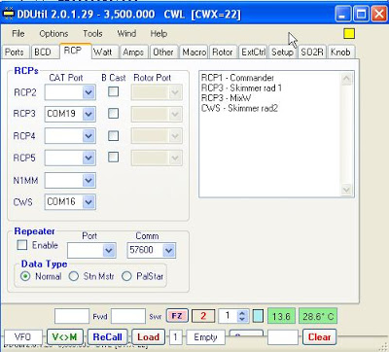

“But wait the 6-16 Radio 2 pair is connected to a port called CWS (CWskimmer)
The reason for this is port CWS does some magic. If I am using radio 1 and I click the skimmer waterfall it sets the VFO A freq”
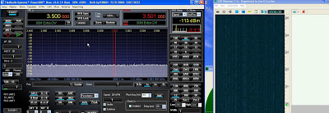

“Note how VFO A changes from 3500 to 3503.980”
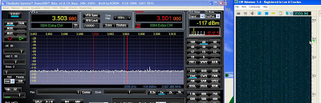

“This is normal behaviour for Skimmer BUT by changing to the Radio 2 6-16 pair I can control my transmit VFO.”
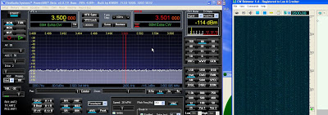

“In this case when I click Skimmer my transmit VFO (VFO B) changes freq. from 3501 to 3504”
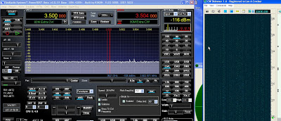

“Imagine you are in a pile up and want to change the transmitter freq all over the pileup as you see different stations working the DX. You merely click the waterfall and there you are transmitting on the freq of your desire, and there is NO CHANGE in the RX freq.”
*********************************************************************************************************

So, after reading this, I decided to apply the above principle for my very final configuration:

MY HARDWARE CONFIGURATION

- Genesis G11 low-power SDR TRX used only for RX, sharing the antennas with FT1000MP
- EMU0204 external USB Sound Card connected to G11
- FT1000MP used as TX (and backup-radio), synchronized with SDR
- MicroHam Microkeyer II, controlling FT1000MP and other devices
- 4-el SteppIR control box, following TX frequency via MKeyer II output
- Remote Antenna Switch driven by BCD/Decimal matrix from FT1000MP BCD band output
- ELAD RX/TX AF/RF Switch Box
- Yaesy G-2800SDX antenna rotator driven by DX4WIN logger country bearing
- 500 Watt RF Linear Power Amplifier, PTT controlled by MicroHam Keyer.
- Windows 7 Dell Vostro 3700 Laptop PC with powered USB ports extender and external monitor.

MY SOFTWARE CONFIGURATION AND SETUPS

Besides of many additional HAM applications, my basic operating configuration consists of:

- GSDR (PowerSDR derived) SDR Control Console, controlled via DDUtil by loggers and CWS
- DDUtil V. 3 Router
- MicroHAM USB router controlling FT1000MP and creating virtual ports
- EMU Control Panel for Sound Card control
- VAC4 Virtual Audio Cable app (http://software.muzychenko.net/eng/vac.htm )
- DX4WIN logger
- WinTest logger
- CW Skimmer
- VE7CC DX Cluster app

Configuration of principal tabs of above applications is represented below:

microHAM MK2 USB ROUTER:

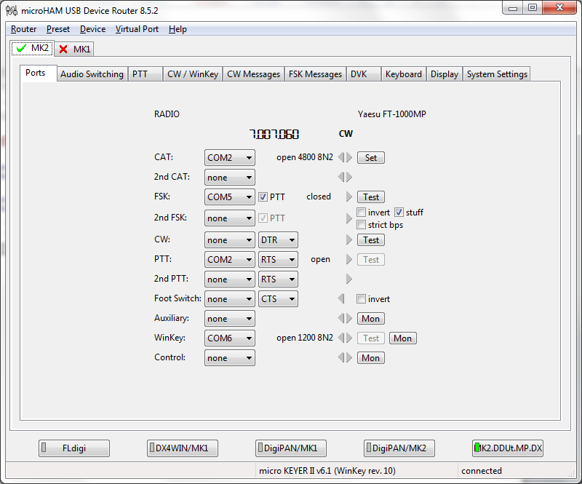

VIRTUAL PORTS ATTRIBUTION (ports/cables created via Router Virtual Ports Menu)

DDUTIL ITEM | CAT PORT | COMPORT | APPLICATION
LEGACY RADIO | 19 | 9 | GSDR CONSOLE SDR CAT
RCP1 | 16 | 15 | DX4WIN LOGGER ( SDR/Flex)
RCP2 | 14 | 13 | CW SKIMMER RADIO 1
RCP3 | 11 | 10 | WINTEST
RCP4
RCP5
CWS | 18 | 17 | CW SKIMMER RADIO 2
PASIVE LISTENER | 2 | 2 | FT1000MP/MK2 ROUTER CMDS

GSDR Console with VAC activated in CW mode for Skimmer use:
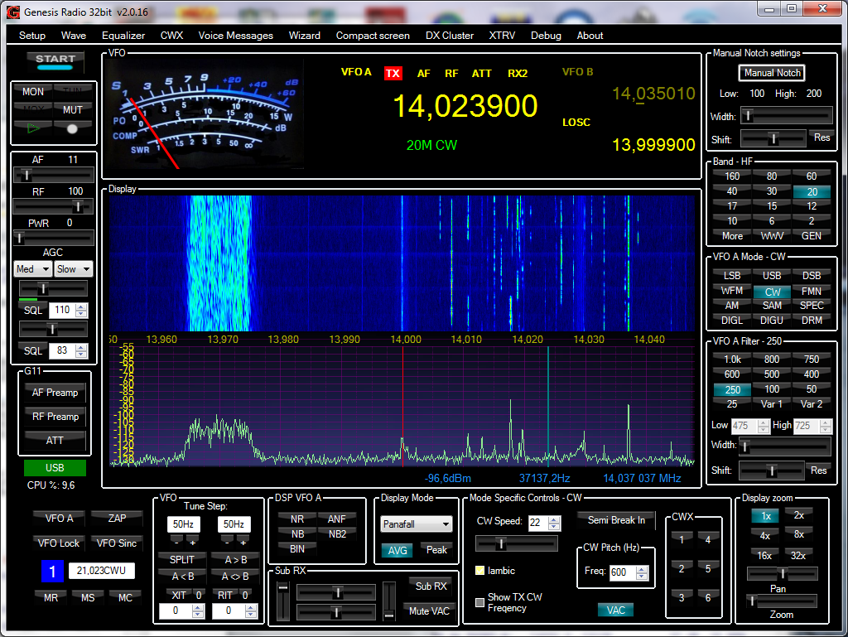

GSDR H/W Setup window:
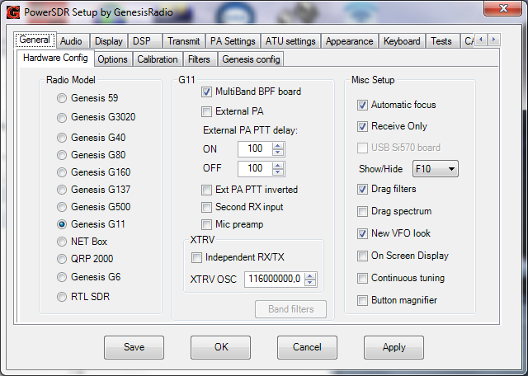

Options Setup window:
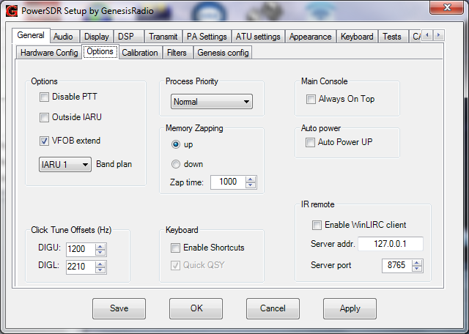

Audio Setup window:
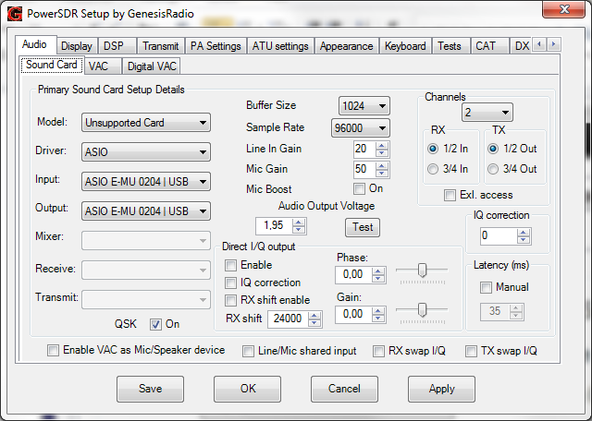

CAT Setup window:

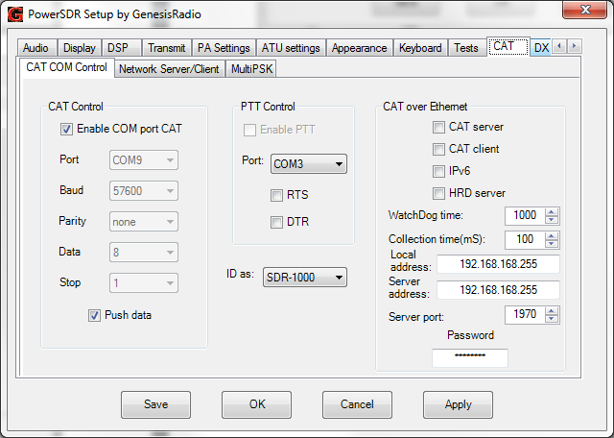

VAC PANEL CONFIGURATION (opened with VAC Control panel Desktop Shortcut)

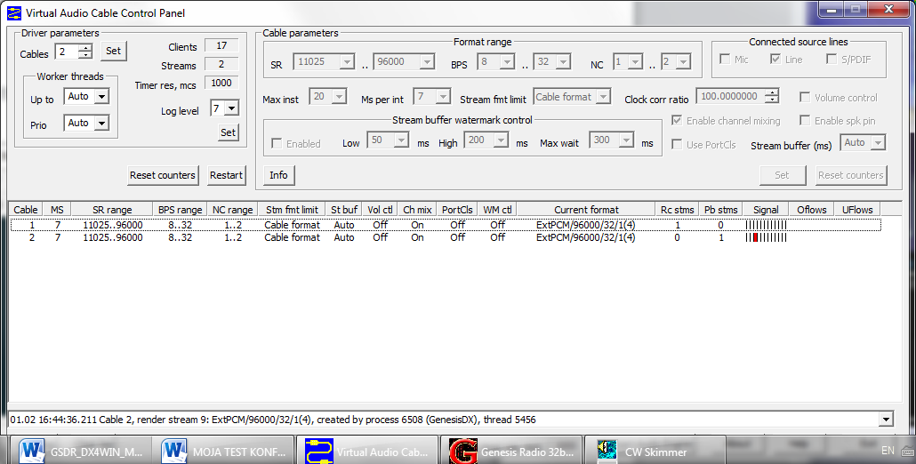

TWO-VAC CABLE CONFIGURATION FOR CW SKIMMER INTEGRATION
WDM-KS works with lower latency than MME (change latency if popping)

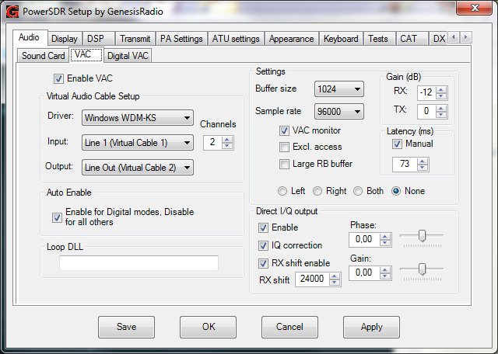

In this configuration, with VAC activated on GSDR Console, frequencies should be selected only by clicking on Skimmer waterfall display or on decoded calls. The reason being is that with frequency change and RX shift enabled, LO changes w. frequency and whole GSDR frequency display moves left-right. So, this GSDR window should be ignored and only CWS window should be used for controlling SDR frequencies.

DDUtil Settings:
SDR Type and Port selection:
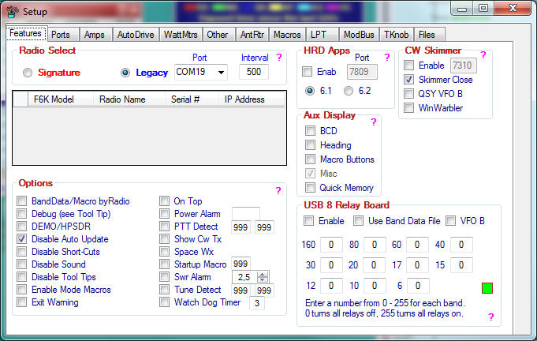

DDUtil Ports configuration window:
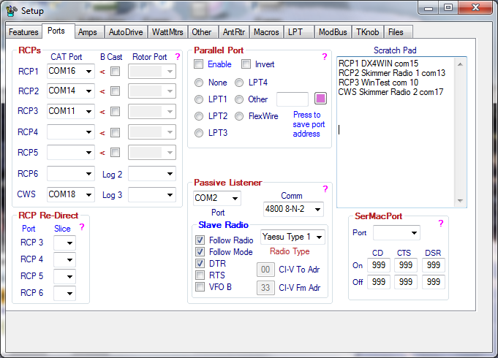

CW SKIMMER WINDOW
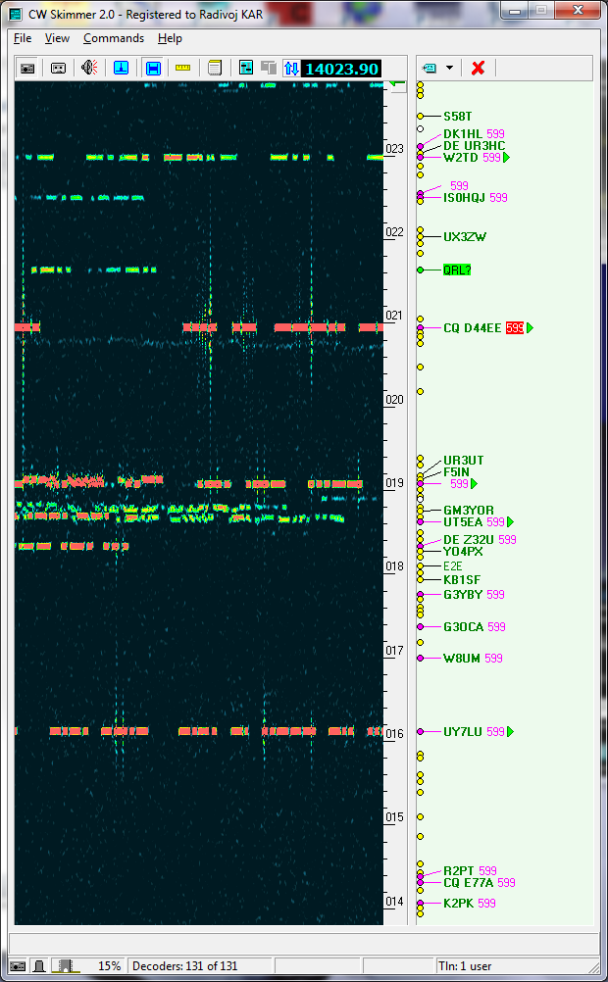

CW SKIMMER CONFIGURATION:

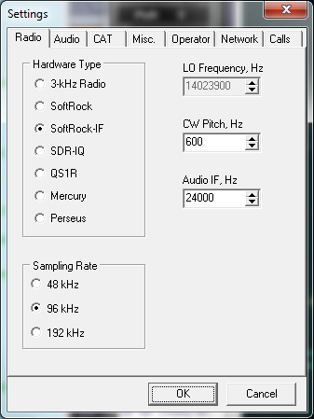 | 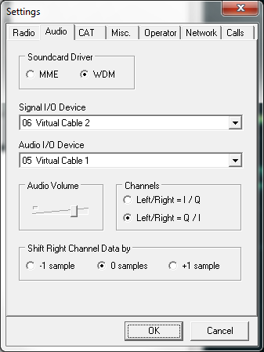
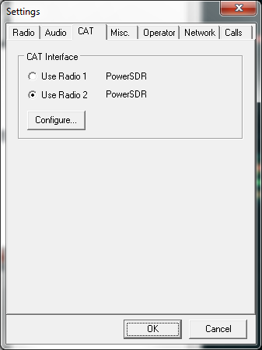 | 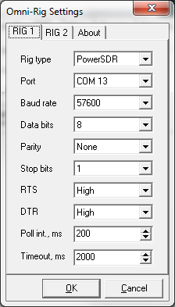
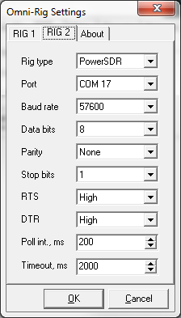 | 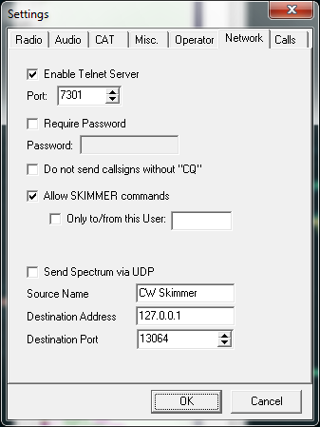

Selecting Radio 1 : CWS click sets vfoA for simplex operation.
Radio 2 is used for Split: CWS click sets vfoB frequency when GSDR/PSDR is in Split mode.
But when SDR not in split, w. Radio 2 selected, CWS click sets vfoA; so Radio 2 can be kept selected all time!

OPERATING PROCEDURES

First and very important, is the order of launching of different software applications, which have been pre-configured for intended use:

- microHAM USB Device Router
- DDUtil (will display “not connected” until GSDR is launched)
- GSDR/PSDR Console
- Logging program
- CW Skimmer

Operation w. CW Skimmer:

Following table illustrates what happens after click on CW Skimmer’s frequency/waterfall:

STATUS | SDR RX | SDR TX | Slave TX  (vfoB OFF) | Slave TX  (vfoB ON)
SDR in Simplex Mode | vfoA | vfoA | sdr vfoA | last sdr vfoB
SDR in Split Mode | last vfoA | vfoB | sdr vfoB | sdr vfoB

Remarx:
SDR in Split Mode: to avoid, by erroneous manipulation, changing receiving vfoA frequency and missing DX-ped’s response, click on “lock vfoA” on GSDR/PSDR Console!

Operation w/o CWS (SSB, CW , other modes..)

Reminders:
- Do not forget to disable VAC on GSDR/PSDR CW window after leaving CWS Mode!
- SDR TX vfoB selection (red cursor) is activated by double right mouse click.

Following table illustrates what happens after click on GSDR/PSDR frequency/waterfall:

STATUS | SDR RX | SDR TX | Slave TX  (vfoB OFF) | Slave TX  (vfoB ON)
SDR in Simplex Mode | vfoA | vfoA | sdr vfoA | last sdr vfoB
SDR in Split Mode | last vfoA | vfoB | sdr vfoB | sdr vfoB

Conclusion: Slave Radio vfoB can be kept always unchecked

73 and good DX with SDR,

Radi, F6GNZ
(f6gnz@yahoo.com)

